**STUDENT RESULT PROCESSING MANAGEMENTSYSTEM**

**Introduction**

This project aims to develop a robust SQL-based system for managing student grades and calculating CGPA using MySQL. By designing a structured relational schema and implementing advanced query logic, the system provides a scalable solution for academic performance tracking.

**Objective**

To build a MySQL system that efficiently manages student grades, computes GPA/CGPA, and generates insightful academic reports.

**Tools used**

Database**:** MySQL

**Mini Guide**

1. Schema Design: Define tables for Students, Courses, Grades, and Semesters with appropriate relationships.
2. Data Insertion: Populate the database with student records and exam results.
3. Query Development: Write SQL queries to calculate GPA, CGPA, and pass/fail statistics.
4. Ranking Logic: Use window functions to generate rank lists based on academic performance.
5. Triggers: Implement triggers to automate GPA calculations upon grade entry.
6. Result Export: Generate semester-wise result summaries for reporting and analysis**.**

**Deliverables**

* Grade reports with pass/fail analysis
* SQL schema with table definitions and relationships
* GPA and CGPA calculation logic
* Rank list queries using window functions

**Database Schema Design**

* The database schema is designed to capture essential academic data and support efficient GPA/CGPA computation. It consists of the following core tables:

**1. Students**

* Stores basic information about each student.

| **Column Name** | **Data Type** | **Description** |
| --- | --- | --- |
| student_id | INT (PK) | Unique identifier |
| name | VARCHAR | Full name |
| dob | DATE | Date of birth |
| department | VARCHAR | Academic department |

**2. Courses**

* Defines the courses offered in each semester.

| **Column Name** | **Data Type** | **Description** |
| --- | --- | --- |
| course_id | INT (PK) | Unique course identifier |
| course_name | VARCHAR | Name of the course |
| credits | INT | Credit value of the course |
| semester_id | INT (FK) | Linked semester |

**3. Semesters**

* Tracks academic semesters.

| **Column Name** | **Data Type** | **Description** |
| --- | --- | --- |
| semester_id | INT (PK) | Unique semester identifier |
| semester_name | VARCHAR | Name (e.g., "Sem 1") |
| year | INT | Academic year |

**4. Exams**

* Stores exam details for each course.

| **Column Name** | **Data Type** | **Description** |
| --- | --- | --- |
| exam_id | INT (PK) | Unique exam identifier |
| course_id | INT (FK) | Related course |
| exam_type | VARCHAR | Type (e.g., Midterm, Final) |
| max_marks | INT | Maximum marks |

**5. Grades**

* Captures student performance in exams.

| **Column Name** | **Data Type** | **Description** |
| --- | --- | --- |
| grade_id | INT (PK) | Unique grade entry |
| student_id | INT (FK) | Student who took the exam |
| exam_id | INT (FK) | Exam attempted |
| marks_obtained | INT | Marks scored |
| grade | CHAR | Grade (e.g., A, B, C, F) |
|  |  |  |

**ER DIAGRAM**

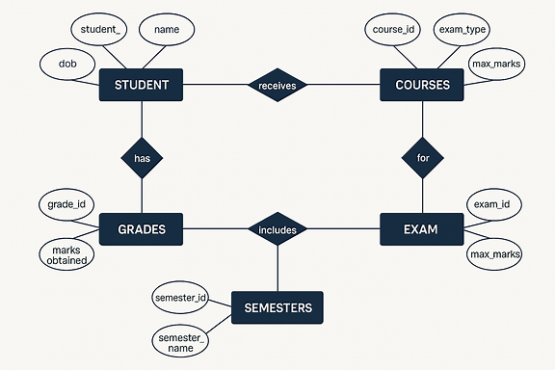

* Students are linked to Grades through their performance
* Courses are tied to both Semesters and Exams
* Grades connect students to specific Exams
* Each entity includes its key attributes and relationships

**Schema for the tables and viewa**

1.students

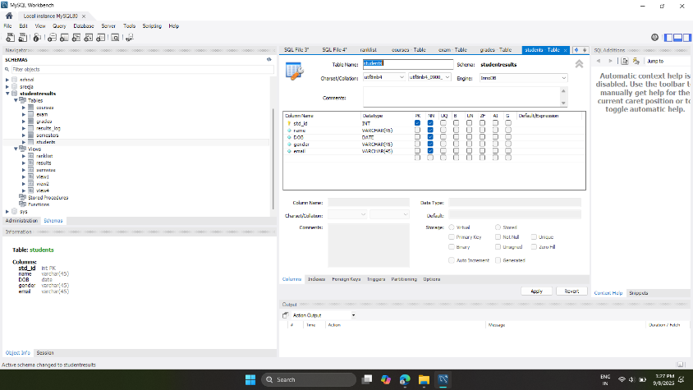

2.exams

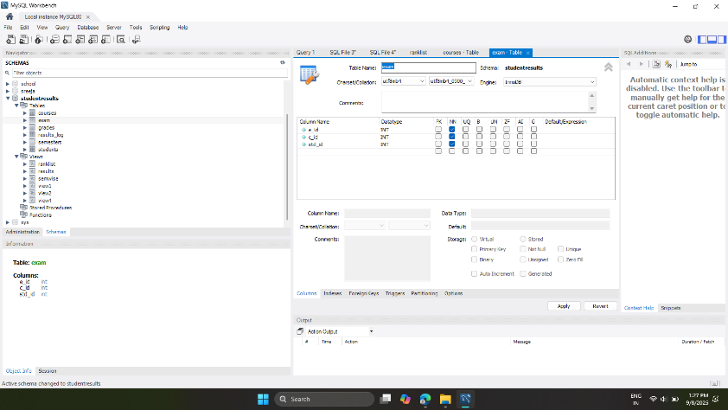

3.semesters

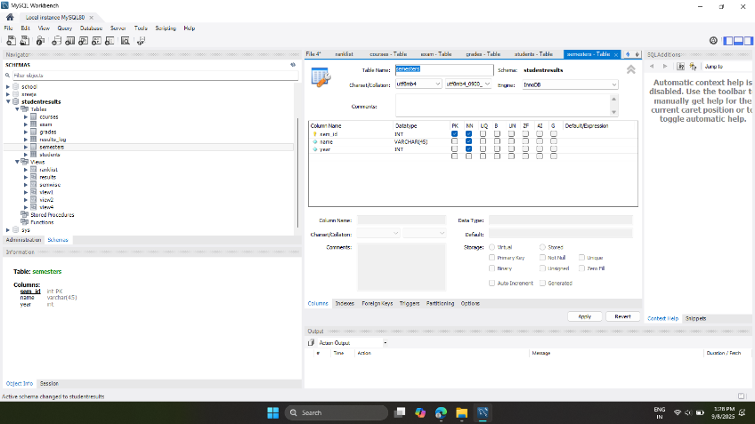

4.courses

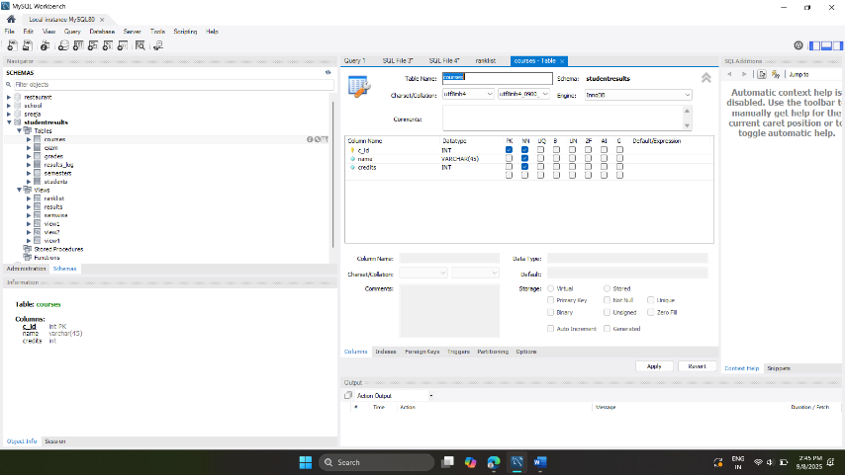

5. results_log : view

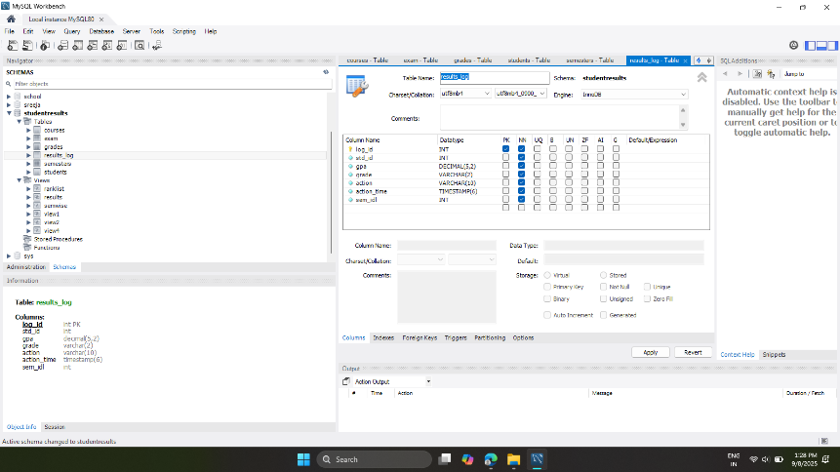

6.ranklist view

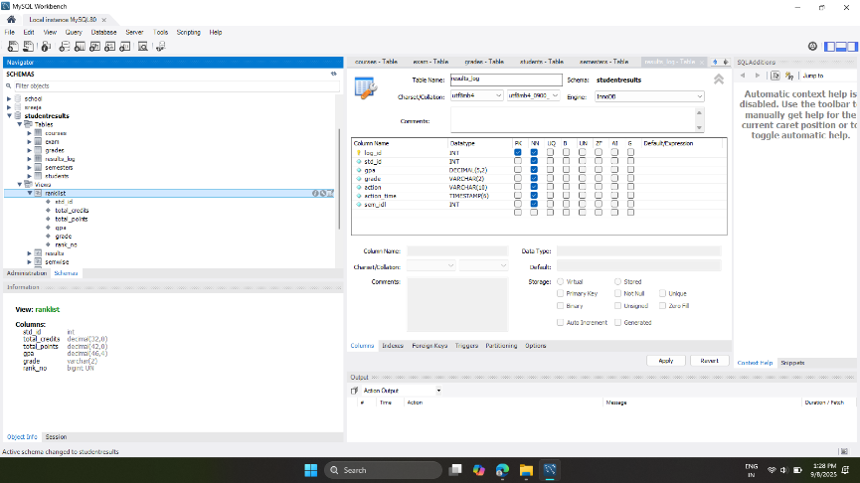

7.semwise view

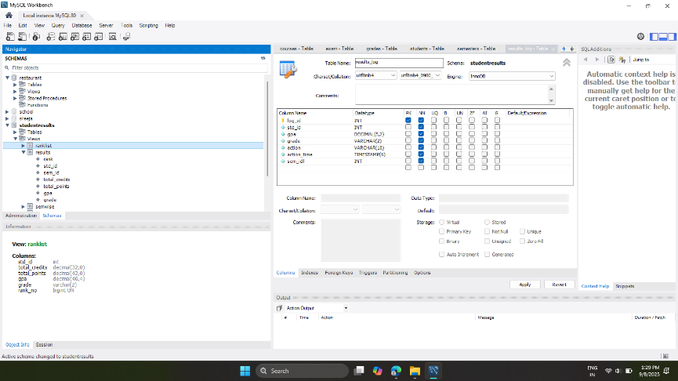

8.view4

